## Experiment Name: Priority scheduling algorithm.

## Experiment No: 06

***Priority scheduling Algorithm:***

In priority scheduling algorithm each process has a priority associated with it and as each process hits the queue, it is stored in based on its priority so that process with higher priority are dealt with first. It should be noted that equal priority processes are scheduled in FCFS order.

To prevent high priority processes from running indefinitely the scheduler may decrease the priority of the currently running process at each clock tick (i.e., at each clock interrupt).

**Pseudo Code:**

#include<stdio.h>

int main()

{

int bt[20],p[20],wt[20],tat[20],pr[20],i,j,n,total=0,pos,temp,avg_wt,avg_tat;

printf("Enter Total Number of Process:");

scanf("%d",&n);

printf("\nEnter Burst Time and Priority\n");

for(i=0;i<n;i++)

{

printf("\nP[%d]\n",i+1);

printf("Burst Time:");

scanf("%d",&bt[i]);

printf("Priority:");

scanf("%d",&pr[i]);

p[i]=i+1; //contains process number

}

//sorting burst time, priority and process number in ascending order using selection sort

for(i=0;i<n;i++)

{

pos=i;

for(j=i+1;j<n;j++)

{

if(pr[j]<pr[pos])

pos=j;

}

temp=pr[i];

pr[i]=pr[pos];

pr[pos]=temp;

temp=bt[i];

bt[i]=bt[pos];

bt[pos]=temp;

temp=p[i];

p[i]=p[pos];

p[pos]=temp;

}

wt[0]=0; //waiting time for first process is zero

//calculate waiting time

for(i=1;i<n;i++)

{

wt[i]=0;

for(j=0;j<i;j++)

wt[i]+=bt[j];

total+=wt[i];

}

avg_wt=total/n; //average waiting time

total=0;

printf("\nProcess\t Burst Time \tWaiting Time\tTurnaround Time");

for(i=0;i<n;i++)

{

tat[i]=bt[i]+wt[i]; //calculate turnaround time

total+=tat[i];

printf("\nP[%d]\t\t %d\t\t %d\t\t\t%d",p[i],bt[i],wt[i],tat[i]);

}

avg_tat=total/n; //average turnaround time

printf("\n\nAverage Waiting Time=%d",avg_wt);

printf("\nAverage Turnaround Time=%d\n",avg_tat);

return 0;

}

**Output:**

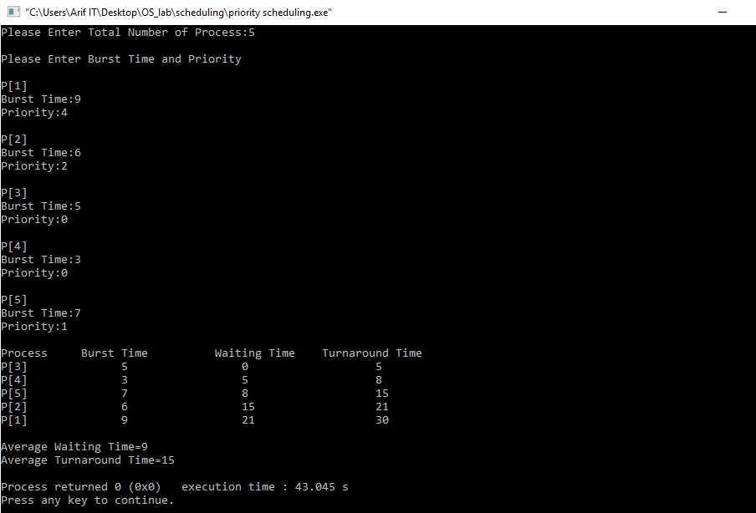

Discussion : After the successfully implementation of priority Scheduling algorithm, we learn how a priority is assigned to each process and how priority is allowed to run. Higher priority process will executed first and then the lower priority and so on.